Project Progress Report

ITEA 3

Version 5 December 2017

Foreword

Do not remove or modify in any way the sections having these notations,

All guidelines in the template appear in this “boxed” format. These instructions, as well as the preceding title page (“PPR Annex template”) and this foreword, should never be removed manually from the submitted files: they are automatically removed by the merging function of the ITEA Community website. Potential layout issues appearing when removing the instructions (e.g. a large image leaving half a page blank) will be adjusted by the ITEA Office, between the report submission and the transfer of the generated PPR to the reviewers.

NB: all texts between “<” and “>” symbols (incl. on the front page and in the headers) should be replaced or removed.

It is highly recommended that you carefully read all the instructions provided: they indicate for each chapter and subchapter what is expected, and must be carefully taken into account.

It is crucial that report writers comply with the pre-defined formatting and styling rules: breaking these rules may create errors when inserting the auto-generated sections and thus cause the merge process to fail. Complying with formatting rules can be achieved by adhering to the following guidelines:

* do not remove any predefined title and do not add headers, incl. annexes, that are not supposed to be defined according to this template, at any level of the hierarchy
* do not modify the predefined styles, except for standard “emphasis” effects (i.e. underlined or bold text) – we recommend using the underlined and bold formatting in a consistent and prudent way throughout the document, and on body text exclusively;
* only use the pre-defined styles that start with “ITEA_”: the most relevant ones are “ITEA_BodyText” for standard paragraphs (Arial 10 with a line spacing factor of 1.2 pt), “ITEA_BodyBullets” for bullet points within standard paragraphs and “ITEA_Figure”; for captions, you can use the standard “Insert Caption” function from Word, as it will automatically use the “ITEA_Caption” styling; these styles are accessible in the “Quick Styles Gallery” of the “Home” tab;
* do not remove the instructions (both green and orange ones), and do not remove the auto-generated sections;
* do not overload the document with uncompressed / excessively large images; a report should ideally fit in less than 10 MB.

It is in the interest of consortia to ensure that a merged document (i.e. including auto-generated sections) can be generated and downloaded before the submission deadline so that all the relevant information is provided in the project progress report.

20XX-HX Project Progress Report Annex

<ACRONYM> or <PROJECT NAME>

<FULL PROJECT NAME>

Edited by: < >

Date: < >

Project key data

Auto-generated section: input to be provided only on the Community website. Do not edit or remove this box and do not provide any text within this annex in this chapter, but provide the request information directly on the ITEA Community website.

The inserted key data will contain (among others) acronym, full title, time frame, the respective countries and partners per country, the coordinator, project status as well as PCA status.

**Project Acronyms**

|  |  |
| --- | --- |
| <ACR> | <Acronyms> |
| < > | < > |
|  |  |
|  |  |

Table of Contents

Foreword 2

Project key data 4

1. Project one page description 7

2. Project overall status 8

2.1. Top 4 overall targeted innovations 8

2.2. Top 4 overall targeted business impacts 16

2.3. Top 4 overall project result KPIs 18

2.4. Top 4 overall risks 20

2.5. Changes in the technology and business during the reporting period 23

3. Exploitation 24

3.1. Partners’ market access 24

3.2. Top 8 overall partners’ Exploitation Related Achievements 25

3.3. Realised Exploitation Related Achievements 25

4. Project progress during the reporting period 26

4.1. Overarching work progress during the reporting period and issues 26

4.2. Details of technical progress per work package 31

4.3. Per partner progress during the reporting period 31

5. Feedback to previous STG remarks 33

1. Project one page description

Auto-generated section: this section is filled with *§1. Project one page description* from the latest approved FPP.

Do not remove or modify in any way the sections having these notations throughout the whole Annex template since they are needed to automatically merge the information provided via the ITEA Community website with your uploaded Annex document.

1. Project overall status
   1. Top 4 overall targeted innovations

Define the top 4 targeted innovations for the whole project, i.e. the innovative results the project aims to achieve before its closure. Avoid generic terms, remain brief and to the point, by focusing on what the project really brings new to the table. For each targeted innovation, please indicate:

* the main contributors (only the key contributors are expected there, not the exhaustive list of all contributors)
* short descriptions and the current state-of-the-art related to the proposed innovation. The provided descriptions should be detailed enough to be self-explanatory approximately in 50-100 words per innovation.

Please note that innovations are not necessarily deliverables per se.















|  |
| --- |
| **1. Intelligent advertisement will adapt to real-time traffic information.** |

***Main contributors***: <Gerade, KoçSistem, Verisun, Argedor,Ezeris>

***Description for innovation and state-of-the-Art***:

The density of traffic in cities can be identified by surveillance system. Surveillance system acquires the data from events in the cities (like theatre,cinema,sorts etc). Data acquired by heterogeneous and diverse systems are being pre-processed and analysed in real time with machine learning algorithms. These data are being deployed to the application embedded in hardware to be used .. It also supports intelligent advertising systems that contributes to market. The flow of advertisement will change in accordance with public wait times and crowd.

|  |
| --- |
| **2. Integration of the live bus and stop information into the INSIST platform.** |

***Main contributors***: < Gerade, Koc Sistem,Ezeris >

***Description for innovation and state-of-the-Art***

Insist will be integrated with municipality system. Thus, data belonging to each bus will be retrieved from municipality system and exploited for analysis. Via visual-social-map sensors, data will pre-process with advanced data mining algorithms. The data acquired by various sensors will be contextualized and computed to extract meaningful context for local events that will increase data granularity,

The screens from smart bus stop application are given below:

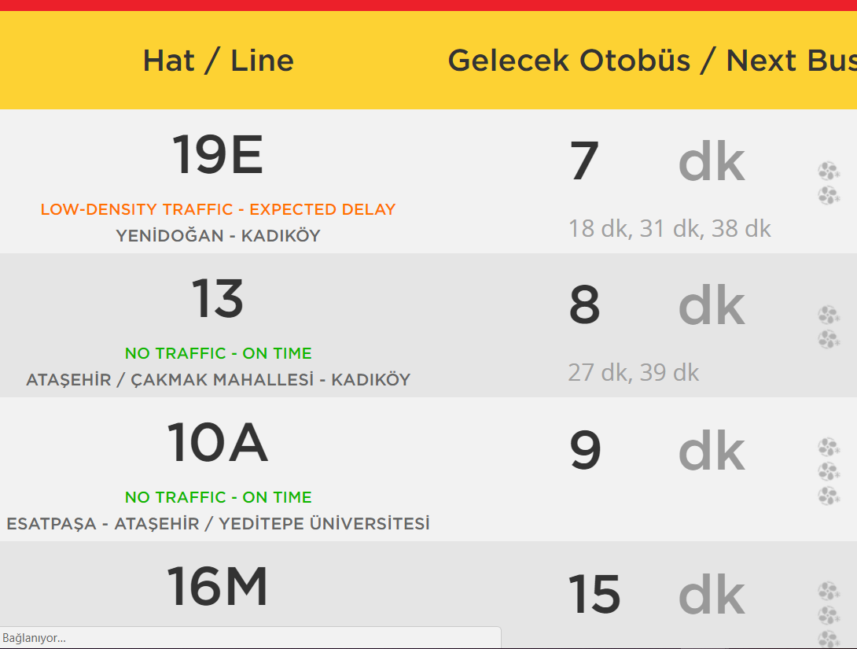

Figure 2 1.1. The smart bus stop application screen

|  |
| --- |
| **3.Development of a big data analysis ready open database accessible by INSIST services to exchange information and events.** |

***Main contributors***: <Gerade, Argedor >

***Description for innovation and state-of-the-Art***:

Data management system will be intelligent mixture of AES,TLS and SHA-2. JSON and RESTful platform will be used to establish communication content that will provide data retrieval from heterogenous network.To provide asset tracking,vehicle count and unexpected event forecasting and data extraction, CPP infrastructure will be the basis of the system.

|  |
| --- |
| **4. Mobile Application for Urgent Cases** |

***Main contributors***: <Verisun.Kocsistem >

***Description for innovation and state-of-the-Art***:

This application helps officers(doctors, police officer, the field manager responsible for road construction and maintenance) take immediate action and generate report in case of urgent cases resulting in discrepancy and traffic congestion. Thus, a hundreds of lives might be saved and the costs related to time and budget might be minimized. As well as    one of the most important improvement provided by the project is speed and accuracy. It will minimize possible traffic congestion with central management. a

All the screens taken from mobile application are displayed below.

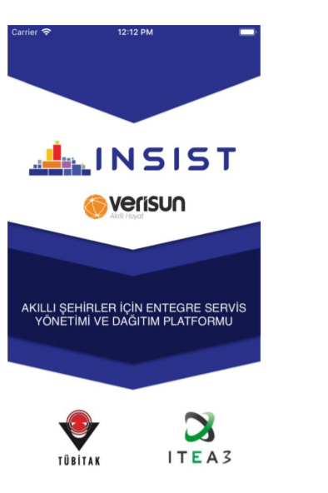

Figure 2 1.1. Splash Screen

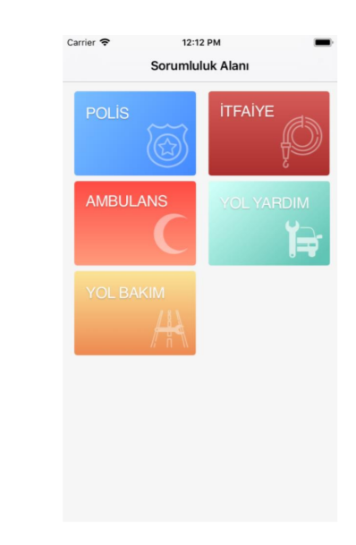

Figure 2 1.2. Splash Screen



Figure 2.1.3 Job Field’s screen

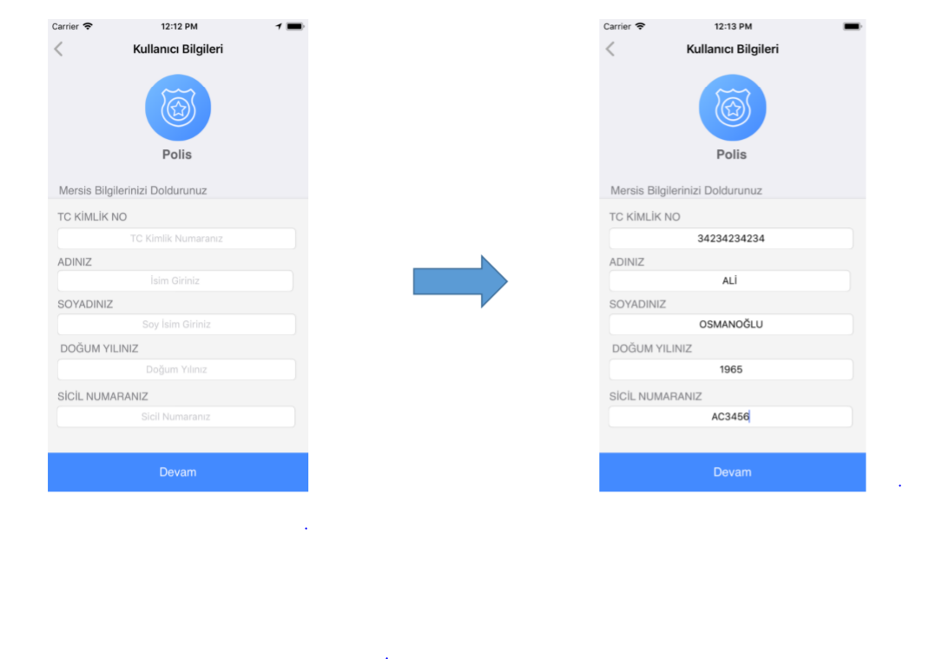

Figure 2.1.3 account registration

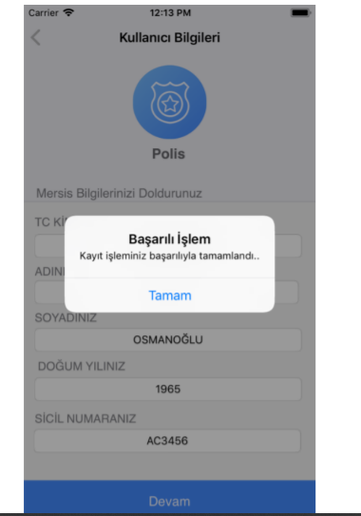

Figure 2.1.3 account creation screen

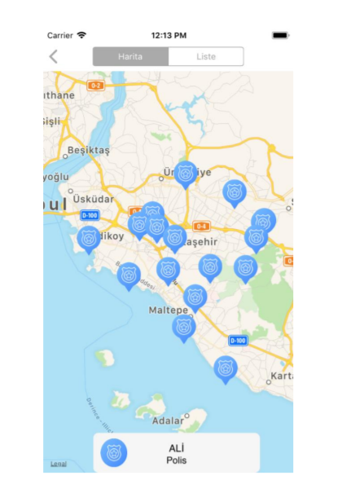

Figure 2.1.4 The map displaying the closest incident location screen

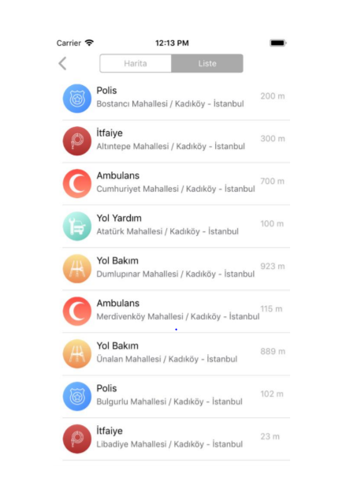

Figure 2.1.5 The list of the closest incident locations screen

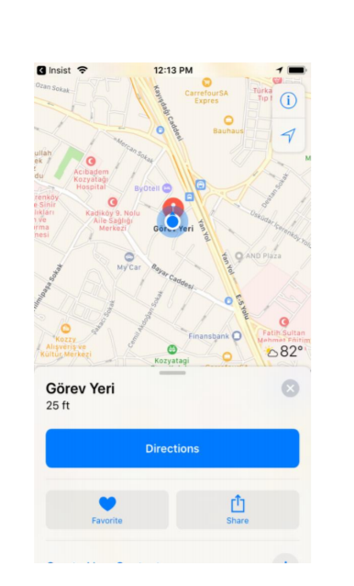

Figure 2.1.6 The Route Navigation screen

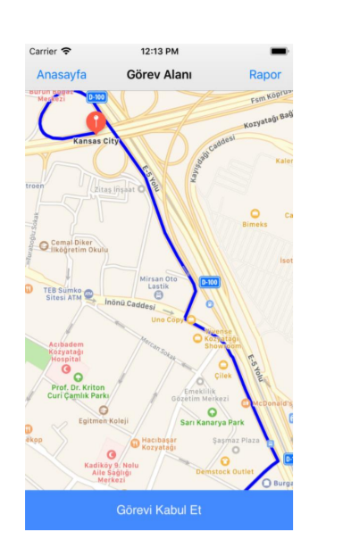

Figure 2.1.7 Mission confirmation screen

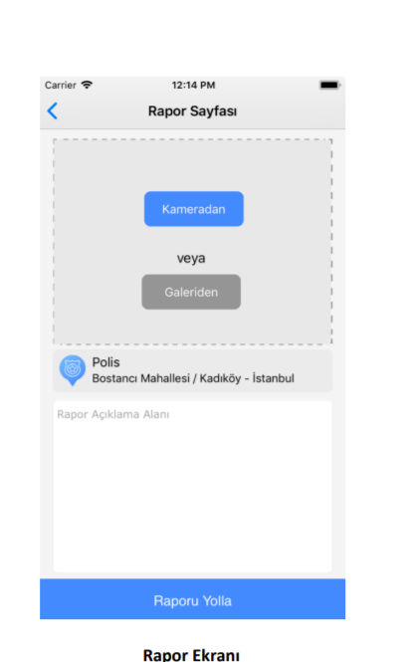

Figure 2.1.8 Reporting screen

|  |
| --- |
| **4. A distributed, extensible, flexible architecture, supporting real-time video-based presence sensing, including network interfaces for the exchange of information** |

***Main contributors***: <Gerade, Argedor, KoçSistem,Ezeris >

***Description for innovation and state-of-the-Art***: Based on depth-sensor technologies, system will help record people’s and car’s motions concurrently, capture human behaviour and gestures more precisely so that more accurate customer classification and clustering will be done with the help of statistical based machine learning algorithms. This system will benefit from understanding of 3D scenes, handling occlusions and the robustness to changing lighting conditions. There will be three different sensor types which are visual, social sensor used detecting traffic status, road conditions and displaying if some hazardous events arisen(traffic accident) from social media ,map sensor revealing traffic density based on each region to detect traffic density and to be used for data retrieval to increase accuracy. The flow of traffic sourced by public transportation usage will be accelerated and lessened. The extendibility, scalability and robustness of system will be enhanced by Business Intelligence application.

Copy the above template, if more targeted innovations need to be indicated.

* 1. Top 4 overall targeted business impacts

Define the top 4 targeted business impacts for the whole project, i.e. the exploitation results the project aims to have achieved by and after closure. Avoid generic terms, remain brief and to the point, by focusing on what the project actually expects to achieve business-wise thanks to the project’s technical results. For each targeted business impact, please indicate:

* Short description for business impact
* the main contributors (only the key contributors are expected there, not the exhaustive list of all contributors)
* the targeted market and its current competitors approximately in 50-100 words per impact.















|  |
| --- |
| **1. *Better monitoring the road network and providing intelligence to decision makers by using cameras and social media technologies*** |

HD related camera facilities and hardware’s’ costs are lowered by the technological advancements. This system strengthened by image recognition based algorithms has become more popular in the market. Making use of this type of technology enhanced by machine learning based algorithms and integrated with social platforms helps the officers and big municipalities identify safety and security related problems easily and accurately , guides them to establish a good work management and strategy that increases surveillance of people who are in the traffic and public areas . INSIST also aims to define point based bus-based traffic problems associated with public transportation scheduling and planning, hence municipalities can take timely intervention.

***Main contributors***: Verisun, Argedor

***Market/competitors***:

|  |
| --- |
| **2. People Tracking Systems and Traffic Governance Optimization** |

Since public transportation in the heavy-traffic cities is one of the tough issues for citizens' safety and comfort, INSIST improves context - aware detection techniques for monitoring and collecting traffic related information, in the INSIST project

The experiences gained through the project steps will encourage other investors and professionals to allocate more budget for RD based products and projects. With the use of advanced technologies, Industry 4.0 transformation can be more adaptable and easy-to-use for corporates and SME(small-medium enterprises. There are tremendous number of traffic accidents and traffic-congestions related issues happening annually. Adapting INSIST into municipalities will ease traffic governance and management as well as contribute to propose what other type of solutions can be improved. Introducing smart city technologies will help people and city officer to optimize city and governmental operations in an organized way. The city officers can respond to the complaints or wishes from pedestrians and drivers by gathering information via social media platform. With the help of increasing number of people contribution on social media platform, officers can take precautions against unexpected events and handle traffic issues in shortest time as well as surveillance and safety can be maintained easily

***Main contributors***: Verisun, Argedor

***Market/competitors***:

|  |
| --- |
| **3. New services creation based on the information retrieval from urban-sensor based devices** |

With depth sense sensor based technologies, creating new services matters for accurate data retrieval and transmission from diverse resources. Pre-processed data is contextualized via deep learning and statistical based algorithms. Data fusion from heterogeneous resource will be done semantic and relational analysis to increase system reliability. This data will be sent to mobile application to meet people’s requirement regardless of bus line tracking, road status etc. Within the context, Gerade Software also adds city advertorial server to the video advertorial server and new services and sub products are developed to enrich media broadcasting. That leads to a decrease in stress level over traffic and eliminate safety and surveillance concerns*,*

***Main contributors***: KoçSistem, Argedor, Verisun, Gerade

***Market/competitors***:

-

|  |
| --- |
| **4. .Intelligent outdoor advertisement distribution to the screens relevant to the local situation defined by the processed camera and sensor data** |

With the help of data processing and AI-based system, INSIST tries to map the advertorials to right customer segment by tracking and contextualizing the human behaviours in the city. Targeting right customer segment depends on the quality of data retrieved from sensors. To improve the data precision and robustness, INSIST plans to use High dynamic range(HDR) and micro lenses which eliminates light defects and image blurring. With more advanced and higher image quality advertorials can be broadcast on public screens at the right time and attract more people’s attention that helps companies strengthen their market strategy and reach their targets accurately. Addressing right customer segments for companies contributes to their sales growths and more customer engagement. The features in Pixage, developed by Koc Sistem for digital Sistem for digital publishing used in stadiums and events, such as live broadcasting, social media integration, player grouping and tagging, integration with broadcast will enrich the broadcast stream and tracking line events, is integrated with INSIST project

***Main contributors***: KoçSistem, Argedor, Verisun, Gerade

***Market/competitors***:

Copy the above template, if more targeted business impact need to be indicated.

* 1. Top 4 overall project result KPIs

This section relates to §2.3.4, “quantified objectives and quantification criteria”, of the ITEA 3 FPP template. Consider the expected project results (cf. §2.1. Top 4 overall targeted innovations and §2.2. Top 4 overall targeted business impacts), and for each of them define appropriate quantification criteria, i.e. Key Performance Indicators (KPIs).

KPIs should aim at measuring the objective achievements (i.e. the progress towards the goals), as useful tools for both the consortium and the evaluators.

The KPIs section refers to the project’s final goals (not strictly to the reporting period), and as such it is presumably quite stable from one PPR to the next one (except for the current status update). In the lifetime of an ITEA project, the actual project goals may, however, be refined or slightly reoriented (e.g. to adapt to changes in the technological state-of-the-art or in the market environment): in such cases, the project may update its KPIs if needed, so that they fit with the new adapted goals.

In the project progress report, project management related KPIs (such as the number of milestones completed in time) should be excluded.

For each defined KPI, please indicate:

* Status of KPI in the beginning of the project (Initial value).
* the current value, i.e. the current progress status.
* the target value, computed thanks to the defined metric (whenever possible, provide the unit of measurement, e.g. “%”, “ms” or “fps”).
* the metric description, i.e. how the actual values are computed, incl. the reference architecture / hardware / algorithm / data, whenever relevant.















< >

|  |  |  |  |
| --- | --- | --- | --- |
|  | Initial  Value | Targeted value | Current  Value |
| **1. Sensor creation** | 0% | 100% | 90% |

|  |  |  |  |
| --- | --- | --- | --- |
| **2. Smart Bus Station Application displaying bus arrival time and bus line** | 0% | 100% | 79% |

|  |  |  |  |
| --- | --- | --- | --- |
| **3. Multi model route planning** | 0% | 100% | 79% |

|  |  |  |  |
| --- | --- | --- | --- |
| **4. Mobile Application for urgent cases** | 0% | 100% | 79% |

Copy the above template, if more result KPIs need to be indicated.

* 1. Top 4 overall risks

Analyse any possible risk (technological, managerial, commercial, etc.) identified during the reporting period. Identify the top 4 risks for the project, and for each of them, present ideally both:

* an appropriate and realistic avoidance action,
* and an appropriate mitigation / back-up plan, in case the realisation of the risk cannot be avoided, approximately in 30-50 words per risks.

The analysis of commercial risks is crucial during the final year of projects (and recommended for previous years). For each risk, define also:

* its Severity:

- Low: the impact on the project would be mainly collateral (e.g. a partner is leaving, whose tasks can mostly be transferred to remaining partners)

- Medium: the project would be impacted, but the core project outcomes, despite being somehow downsized, would remain very relevant (e.g. the technological breakthrough is not fully achieved, with performances 20% below what was planned, while remaining above the state-of-the-art)

- High: the project would be significantly impacted, with a considerably decreased business impact (e.g. one of the three core partners for the exploitation reshapes its strategic planning and decides to leave the targeted market)

- Critical: the rationale of the project would be at stake, and a complete reshaping of the future goals would be required (e.g. a competitor markets a product comparable to what was planned, two years before the project planned delivery)

* its Probability of occurrence:

- Rare: 1-10 % of chance to occur

- Possible: 10-50 % of chance to occur

- Likely: 50- 90 % of chance to occur

- Almost certain: ≥ 90 % of chance to occur















< >

|  |  |  |
| --- | --- | --- |
|  | Severity | Probability |
| **1. <Budget constraint sourced by economical challenges in Turkey >** | High | Almost certain |

***Avoidance action***:

< Due to economical issues in Turkey( increase in finance cost, economical instability) budget allocation is limited for the sources that limits work capacity resulting in work efficiency and service quality >

***Back-up / mitigation plan***:

<Budget allocation should be rescheduled and optimized by taking into consideration Turkey’s economical status in a long term >

|  |  |  |
| --- | --- | --- |
| **2. Carefully monitor deliverable status and define a mitigation plan** | Medium | Likely |

***Avoidance action***:

< Adding one group member more for the project will leverage business delivery status plan and mitigation will be prepared more well organized >

***Back-up / mitigation plan***:

<Reaching consensus over all to give more attention for deliver tracking >

|  |  |  |
| --- | --- | --- |
| **3.** **For year 3, Data from Madrid should be included and demonstrated in the common database and report at the final review within predefined time** | Medium | Possible |

***Avoidance action***:

< Decision should be taken for from which data sources will be exploited and define a plan how to deploy the data without interruption to handle the time issues >

***Back-up / mitigation plan***:

<Using alternative sources to gather the data within predefined period or preparing pseudo or synthetic data by means of data from Turkey >

|  |  |  |
| --- | --- | --- |
| **4.** Wrong data entrance by end users because of lack of skills | High | Likely |

***Avoidance action***:

<Training end users is most essentoail step to prevent wrong data entrance, prioritizing accuracy over speed is so essential to eliminate the risk factor associated wrong data entrance >

***Back-up / mitigation plan***:

<Data profiling increases accuracy and reliability of system eliminates data redundancy. New software tools reinforcing data verification and validation can be generated. Also single entry and visual checking can be replaced with more effective data entry methods, such as double entry

Copy the above template, if more risks need to be indicated.

* 1. Changes in the technology and business during the reporting period

Reconsider the relevance, importance and impact of the project in particular with respect to the current technological state-of-the-art (as opposed to the one described in the FPP) and to current and forecasted trends. Address possible new or similar related projects. Also document the market relevance changes that occurred since the latest PPR was issued.

Do not refer the changes in technology and business within your project, but report the changes in the external “world”. Do not copy technical and strategic relevance related sections from previous PPRs, and report only on updates and evolutions. If major changes occurred since the latest PPR or FPP release, document such changes in this paragraph. If the technological and business relevance has not changed, state it here.

In a real application of the proposed system in a big city, there happens to be thousands of cameras and social media users falls into the system producing a real big and streaming data. Collection, storage and processing of such data leading to reduction in operation cost is becoming feasible by the developments in technologies such as FO, wireless, narrow-bandwidth, mobile apps, Big Data, GPU, etc.However, installation of wide spread visual sensors is so costly. Each decreasing step in the prices of camera and communication equipment, creates a doubled effect in the increasing rate of the investments in the areas

Within our issues, by the developments in the computation hardware, Ubiquitous / Edge / Fog computing topics create very advantageous improvements. For instance instead of streaming video to a center, making all the computation in the edges and collecting only the output information, raises the chances of installing endless number of cameras throughout the cities.

Technology also provides a new level of safety for smart cities, allowing advanced warning or notifications of events or other activities happening on the route—alert operators, rerouting and also a heads up to the community and the residents enable to take immediate action on the unexpected events in real time.IOT helps optimize routing decision and alerts operation while decreasing labor intensive and repetitive tasks bringing additional cost in case of time and budget. Municipalities can benefit this type of technology integrated with industry specific tools to increase the public’s life span in case of safety, security and surveillance.

1. Exploitation

Each partner has to go to its project specific Partner page on the ITEA Community website to fill in the requested fields:

* § 3.1. Partners’ market access:

The partners’ exploitation prospects (market access) needs to be updated in line with the progress of project, whenever relevant, in the “Partner details” tab – “Market access” field. Before each PPR, partners are responsible for checking their online data and to updating it whenever it is outdated. Please note that this text replaces the exploitation prospects as defined in the FPP, which means partners should not refer to the FPP.

* § 3.2. Top 8 overall partners’ Exploitation Related Achievements & § 3.3 Realised Exploitation Related Achievements:

ERAs can be created and updated in the “Reporting” tab. ERAs are defined at the partner level, but can be shared among several partners (who are then responsible for getting their online inputs aligned and synchronised). Project partners can propose ERA candidates for the project top 8 ERAs but the selection of the top 8 ERAs among the proposed candidates is the responsibility of the project leader. It is recommended to minimise the number of candidates to a reasonable level (so that the project leader has a maximum of ~25 candidates to select from). This may require partners to filter out old top 8 candidates when more recent and more relevant ones appear. The final PPR report will only include selected ERAs (checked star). Non-selected candidates (unchecked star) are discarded from the PPR. Only the 8 first selected ERAs are exported to the final PPR report. It is therefore recommended to only select a maximum of 8 ERAs among the candidates.

Please note that the partner’s technical contact is the only associate with editing rights on these fields, so it is his/her responsibility to ensure they are updated in due time before the PPR submission.

The project leaders are recommended to inform all partners and to request them to have these fields filled in preferably at least one week before the actual PPR deadline.

* 1. Partners’ market access

Auto-generated section: input to be provided only on the Community website.

Do not remove or modify in any way the sections having these notations throughout the whole Annex template since they are needed to automatically merge the information provided via the ITEA Community website with your uploaded Annex document.

* 1. Top 8 overall partners’ Exploitation Related Achievements

Auto-generated section: input to be provided only on the Community website.

Do not remove or modify in any way the sections having these notations throughout the whole Annex template since they are needed to automatically merge the information provided via the ITEA Community website with your uploaded Annex document.

* 1. Realised Exploitation Related Achievements

Auto-generated section: input to be provided only on the Community website.

Do not remove or modify in any way the sections having these notations throughout the whole Annex template since they are needed to automatically merge the information provided via the ITEA Community website with your uploaded Annex document.

1. Project progress during the reporting period
   1. Overarching work progress during the reporting period and issues
      1. Top 4 Technical Achievements

Identify and provide the four main technical achievements actually made within the reporting period (not just deliverables). Focus on results that generate value (or enable value to be generated), i.e. outputs that bring you closer to your innovation and business goals.

This top 4 should provide the current technical highlights of the project that were achieved or completed during the reporting period.

For each identified technical achievement, provide some more details, whenever relevant, for clarifications on the actual nature of the achievement in approximately 50-70 words per achievements.















< >

Copy the above template, if more Technical achievements need to be indicated.

* + 1. Top 4 next technical targets

Identify and provide the four main technical targets planned for the forthcoming reporting period. Provide further details in approximately 50-70 words per target whenever relevant.















< >

|  |
| --- |
| 1. **A data model for high-end applications based on sensors is created and**   **data processing for surveillance, traffic monitoring and advertising is done.** |

All data will be stored as a JSON object , then records will be posted and sent by REST API as a JSON array format . The parameters like type, timestamp, coordinate , serial, number ,brand and model were defined as an attribute system. These data structures were sent to associated software components and application frameworks to use for surveillance, traffic monitoring and advertising.

|  |
| --- |
| **2 Multi model route planning algortihms were developed** |

One of the most challenging problem in multi model route planning systems in transportation network requires preprocessing efforts, space requirements and query time. To eliminate obstacles such as heavy prepocessing and computing driving directions in milliseconds data retrieved from geospatial and proximity based technologies(WIFI ,Bluetooth, WLAN) were transformed to data storage and the processes such as data cleansing, normalization and transformation, component analysis were completed at data discovery step. To contextualize the data, some machine learning based algorithms, deep learning and artificial neural network approaches were applied and optimized and cleansed data were deployed to applications. Via data mining techniques and machine learning approaches, the utilization of communication over devices were performed more accurately.

|  |
| --- |
| **3.City advertorial server and Video advertorial server were integrated successfully** |

The advertisement video streaming to a dedicated IP address which is assumed to be the address corresponding to a screen on a bus stop is achieved. The delays of the arriving bus lines to a bus stop are collected from the common open database, where this data is provided by Verisun, then the streaming list to that bus stop is organized according to both arriving lines (cause the customer might want to show the advertisement for the passengers of a specific bus line) and available time to play (there should be different length video contents in streaming in case of the changes -*Gerade Software also added city advertorial server to the video advertorial server and new services and sub products were developed to enrich media broadcasting. Introducing new servers to the system gained interoperable and optimised mechanism between devices that needs to work together in a synchronized way and concurrently.*

|  |
| --- |
| **4.Mobile application for urgent cases in the city** |

This application helps officers(doctors, police officer, the field manager responsible for road construction and maintenance) take immediate action and generate report in case of urgent cases resulting in discrepancy and traffic congestion. Thus, a hundred of lives might be saved and the costs related to time and budget might be minimized.

Copy the above template, if more Next technical achievements need to be indicated.

* + 1. Top 4 issues

This part should highlight the four main issues the project had to face during the reporting period. Issues can be related to the management, the overall progress, technical bottlenecks, funding, a brand new game-changing competitor, etc. Issues can typically be realised risks that were identified beforehand (they can also be related to unexpected events or results).

For each identified issue:

* provide details in approximately 20-30 words per issue
* indicate the impact on the project;
* explain which mitigation action has been (or will be) set up to solve the issue; clarify if the current situation is the final one related to this issue, or if this is still a remaining impact to be dealt with in approximately 20-30 words.

If needed, the project leader can identify up to 8 issues in the template reviewed by the STG. In this case copy the necessary table rows and insert as new rows. However, it is important to properly select the 4 main ones, as only these will be visible in the final generated PPR.















|  |
| --- |
| 1. **Improving more sensor technologies to provide Seamless data transfer and exchange** |

In order to fulfill its accomplishments different data sources (namely sensors) are planning to use such as Visual, Traffic Map and Social Media:

* Visual Sensor can count the vehicles, evaluate density and interpret the situation by processing traffic view.
* Traffic Map Sensor can retrieve the traffic density along the given public transportation lines (run by the municipality) by querying through open source traffic data supporters such as Google, Yandex, etc.
* Social Media Sensor can collect the data about mentioned events, accidents, etc. by listening the pre-connected Twitter accounts.

At the last but not the least step, all the collected data are fused into “.json” files exploited by the Verisun’s servers, feeding Public Transportation kiosk throughout the İstanbul.

|  |
| --- |
| **2. Report generation and creating dashboards displaying to display traffic congestion and flow for each region I** |

Parallel to the development of the sensors, ubiquitous computing concept has been worked out for making smart cameras, which can record and evaluate the traffic on its own and cast a density report periodically.

|  |
| --- |
| **3. Web based management platform** |

_??????

|  |
| --- |
| **3. Ensuring all software components and application integration** |

????

Copy the above template, if more issues need to be indicated.

* + 1. Status of deliverables

Indicate the status of deliverables by filling in the below table. If available, include the Gantt chart or any other overview that shows the progress of project tasks and deliverables status.

|  |  |  |  |
| --- | --- | --- | --- |
|  |  |  |  |
|  |  |  |  |
|  |  | | |

|  |  |  |
| --- | --- | --- |
| 7 | 7 | 14 |
| 6  D1.1.2 Use case definition and user requirements specification  D1.2.1 System requirements specification  D5.1.1 Data collection  D6.3 Initial dissemination, exploitation and standardisation plan  D.4.3.1 Privacy and Policy Management  D.5.2.1 DEMONSTRATOR COMPONENT EVALUATION REPORT | | |

< >

If available, include the Gantt chart that shows the progress of project tasks and deliverables status

* + 1. Project statement on progress during the reporting period

Discuss the current global status and progress of the overall project in approximately 100 words. Indicate any possible change or delay that occurred during the reporting period, as well as its cause.

Do not report on WPs that are finished or that have not yet started. Do not refer to achievements of previous reporting periods (if such past achievements are required to better understand current achievements, then state clearly that they are from the previous reporting periods).

The level of the international collaboration might be mentioned here whenever relevant.

< The major competence of the Insist project is planned to be the data gathering from various sensors and integration of this data on the common open database which is open for only the project partners now, but is going to be also available for 3rd parties (who would like to develop smart city applications, especially public bus transportation oriented) until the end of the project. Sensor (visual sensor, social sensor and map sensor) data collection, and sharing on the common open database has been achieved, also intelligent streaming which takes into account the public bus transportation traffic data was developed. Data acquisition and analysis part is implemented and the data from Ankara are deployed successfully. Data from Madrid, Barcelona and İstanbul are expected to migrate from the sources by the end of project. Mobile application for urgent cases is developed and Multi Model Route Planning application is improved. Web Based Management Platform to track customer behaviour is expected to be completed.>

* 1. Details of technical progress per work package

The project leader is asked to request all WP leaders (of active WPs) to provide him/her with their WP-specific next technical targets. Each WP leader has to go to the “Work package descriptions” tab for the specific Progress Report - selectable via the **project’s** “Reporting” tab > “Progress reports” subcategory on the ITEA Community website to fill in the requested field:

* From the “Work package descriptions” tab, each WP leader needs to update the description of his/her WP for the current reporting period by selecting the ‘Edit’ icon in the “Description” column. Summarise the technical and quantitative results achieved in the reporting period by providing the equivalent of an “executive summary” for each active Work Package (WP) (maximum 1 page per WP, no lower boundary).
* Do not report on WPs that are finished or that have not yet started. Do not refer to achievements of previous reporting periods (if such past achievements are required to better understand current achievements, then state clearly that they are from the previous reporting periods).

It is recommended that the project leader uses these summaries to provide the “Top 4 technical achievements” (cf. §4.1.1) and the “Top 4 next technical targets” (cf. §4.1.2).

Auto-generated section: input to be provided only on the Community website.

Do not remove or modify in any way the sections having these notations throughout the whole Annex template since they are needed to automatically merge the information provided via the ITEA Community website with your uploaded Annex document.

* 1. Per partner progress during the reporting period

All project partners need to fill in all the required fields in their respective “Reporting” tab on the ITEA Community website. The “Reporting” tab consists of a Report per period section and an Exploitation related achievements (ERAs) report section.

With regards to §4.3.1 Partner’s main contribution and effort and §4.3.2 Actual vs. Planned effort overview, the related fields can be found in the Report per period section.

Partners are asked to provide a short summary (in one or two sentences) of their respective main contributions during the reporting period, as well as actual effort that has been actually invested from its start to the end of the reporting period. In case the difference between planned effort and actual effort are is more than 20%, the cause of the discrepancy must be explained.

* + 1. Partner’s main contribution and effort

Auto-generated section: input to be provided only on the Community website.

Do not remove or modify in any way the sections having these notations throughout the whole Annex template since they are needed to automatically merge the information provided via the ITEA Community website with your uploaded Annex document.

* + 1. Actual vs. Planned effort overview

Auto-generated section: input to be provided only on the Community website.

Do not remove or modify in any way the sections having these notations throughout the whole Annex template since they are needed to automatically merge the information provided via the ITEA Community website with your uploaded Annex document.

1. Feedback to previous STG remarks

This text field is meant for the consortium to react to previous remarks from the Steering Group (STG), i.e. from the latest FPP evaluation, CR evaluation, latest PPR and/ or review. It can also be used to ask for recommendations from the STG (in which case the question should be detailed enough for any feedback to be possible).

< >